Course Code: COMP 100-001

Completed by: Joseph Ghobrial

Student ID: *****8956

Fun and Simplified Assignment: IPO Charts and Algorithms

2025

**Problem 1: Ice Cream Shop**

|  |  |
| --- | --- |
| **IPO Information** | **C# Statements** |
| Input:  numberOfScoops  pricePerScoop  Output:  totalCost  Processing  Algorithm  1.Prompt for numberOfScoops  2.Accept the numberOfScoops  3.Prompt for pricePerScoop  4.Accept the pricePerScoop  5.Calculate totalCost by multiplying numberOfScoops by pricePerScoop  6.Display totalCost | // Input  double numberOfScoops;  double pricePerScoop;  // Output  double totalCost;  // Processing  // no variable needed  // Algorithm  Console.Write("Enter number of scoops added: ");  numberOfScoops = Convert.ToDouble(Console.ReadLine());  Console.Write("Enter price per scoop: $");  pricePerScoop = Convert.ToDouble(Console.ReadLine());  totalCost = numberOfScoops * pricePerScoop;  Console.WriteLine("Total cost of ice-cream for a customer is: $" + totalCost); |

**Desk Check**

**1)Price per Scoop: $2**

**2)Number of Scoops: 5**

**3)Result: $10**

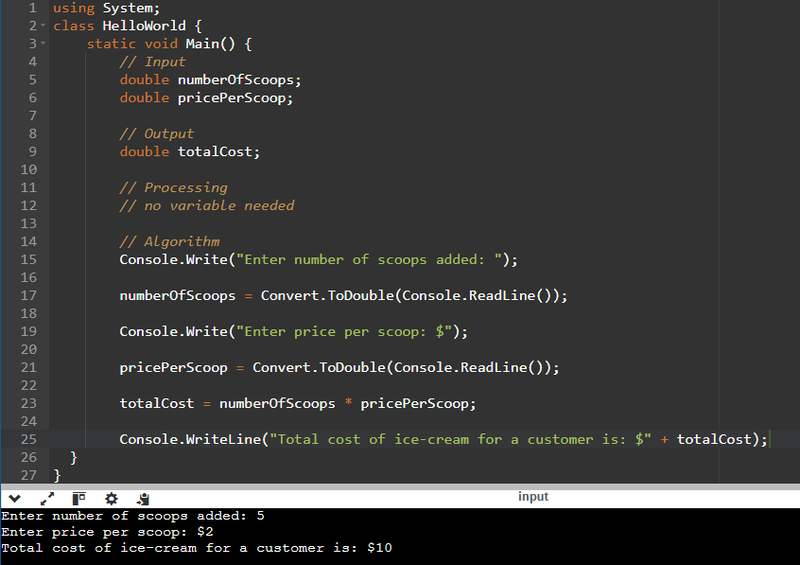

**Problem 2: Pizza Party**

|  |  |
| --- | --- |
| **IPO Information** | **C# Statements** |
| Input:  numberOfPizzas  pricePerPizza  Output:  totalPizzaPartyCost  Processing  Algorithm  1.Prompt for numberOfPizzas  2.Accept the numberOfPizzas  3.Prompt for pricePerPizza  4.Accept the pricePerPizza  5.Calculate totalPizzaPartyCost by multiplying numberOfPizzas and pricePerPizza  6.Display totalPizzaPartyCost | //Input  double numberOfPizzas;  double pricePerPizza;  //Output  double totalPizzaPartyCost;  //Processing  //No variable needed  //Algorithm  Console.Write("How many Pizzas are being ordered?");  numberOfPizzas = Convert.ToDouble(Console.ReadLine());  Console.Write("Enter price per Pizza: $");  pricePerPizza = Convert.ToDouble(Console.ReadLine());  totalPizzaPartyCost = numberOfPizzas * pricePerPizza;  Console.WriteLine ("The total cost of a Pizza Party is: $"+ totalPizzaPartyCost); |

**Desk Check**

**Number of Pizzas: 3**

**Price per Pizza: $11.99**

**Result $35.97**

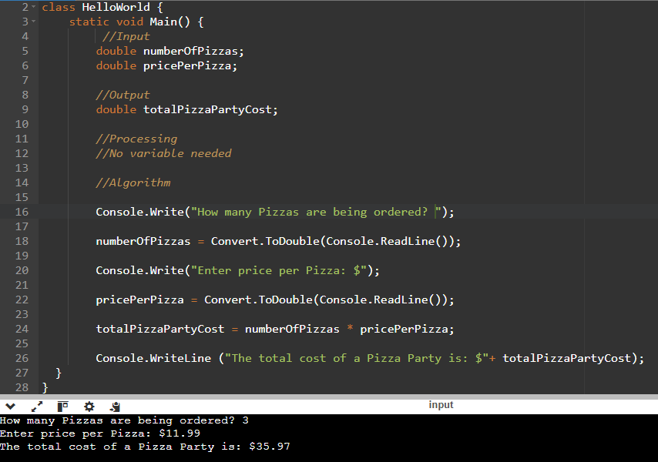

**Problem 3: Bookstore Sale**

|  |  |
| --- | --- |
| **IPO Information** | **C# Statements** |
| Input:  originalPurchasePrice  Output:  newDiscountedAmount  Processing  discountAmount  Algorithm  1.Prompt for originalPurchasePrice  2.Accept the originalPurchasePrice  4. Calculate discountAmount by multiplying originalPurchasePrice by 0.10  3.Calculate newDiscountedAmount by subtracting discountAmount from originalPurchasePrice  6.Display newDiscountedAmount | //Input  double originalPurchasePrice;  //Output  double newDiscountedAmount;  //Processing  double discountAmount;  //Algorithm  Console.Write(“What is the original purchase price of your product? $”);  originalPurchasePrice = Convert.ToDouble (Console.ReadLine());  discountAmount = originalPurchasePrice * .10;  newDiscountedAmount = originalPurchasePrice - discountAmount;  Console.WriteLine(“Your New Purchase Price is: $” + newDiscountedAmount); |

**Desk Check**

**Book price = $50**

**Book price with discount = $50 *.10 = 5**

**New book price = $50 – 5 = $45**

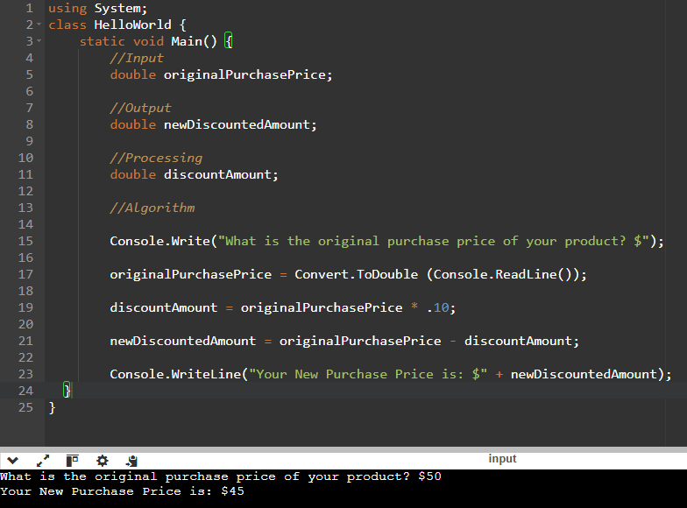

**Problem 4: Movie Tickets**

|  |  |
| --- | --- |
| **IPO Information** | **C# Statements** |
| Input:  numberOfTickets  pricePerTicket  Output:  totalMovieTicketCost  Processing  Algorithm  1.Prompt for numberOfTickets  2.Accept the numberOfTickets  3.Prompt for pricePerTicket  4.Accept the pricePerTicket  5.Calculate totalMovieTicketCost by multiplying numberOfTickets by pricePerTicket  6.Display totalMovieTicketCost | //Input  double numberOfTickets;  double pricePerTicket;  //Output  double totalMovieTicketCost;  //Processing  //No variable needed  //Algorithm  Console.Write("How many tickets did you purchase? ");  numberOfTickets = Convert.ToDouble(Console.ReadLine());  Console.Write("How much did you pay per ticket? $");  pricePerTicket=Convert.ToDouble(Console.ReadLine());  totalMovieTicketCost = numberOfTickets * pricePerTicket;  Console.WriteLine ("Total amount you paid: $" + totalMovieTicketCost); |

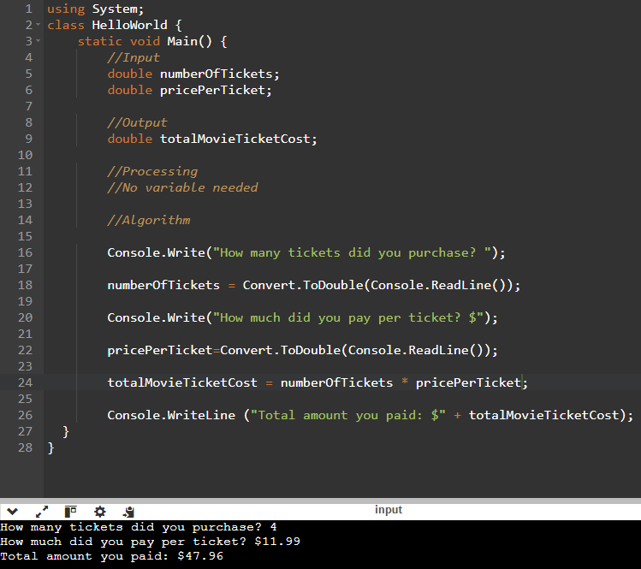

**Desk Check**

**Number of tickets: 4**

**Price per ticket: $11.99**

**Result 4 * $11.99 = $47.96**